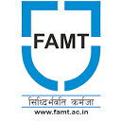

**Finolex Academy of Management & Technology, Ratnagiri**

**Central Library**

**Central Library Held a Vachan Sankalpa Maharashtracha**

Central Library of Finolex Academy of Management & Technology organized a Group Book Reading program on 01st January 2025 at 11.00 a.m. in the central library. A Book Exhibition was also held on the 14th January 2025 under the initiative "Vachan Sankalp Maharashtracha".

The exhibition was inaugurated by Dr Kaushal Prasad (Principal) in the presence of Dr. Yogesh Gajmal (Chairman, LAC), Dr. S B Kulkarni, Prof. Harsha Kelkar, Mr. Mahesh Bhide (Librarian), library staff and students.

Many students participated in the Group Book Reading Program, and visited the exhibition along with the faculty, and staff members.

Mr. Mahesh Bhide (Librarian)coordinated the Group Book Reading program & Book Exhibition with Mr. Vinay Keer and Mr. Suhas Rawanang. The Program was organized under the guidance and support of Dr. Kaushal Prasad (Principal) and Dr. Yogesh Gajmal (Chairman, LAC).

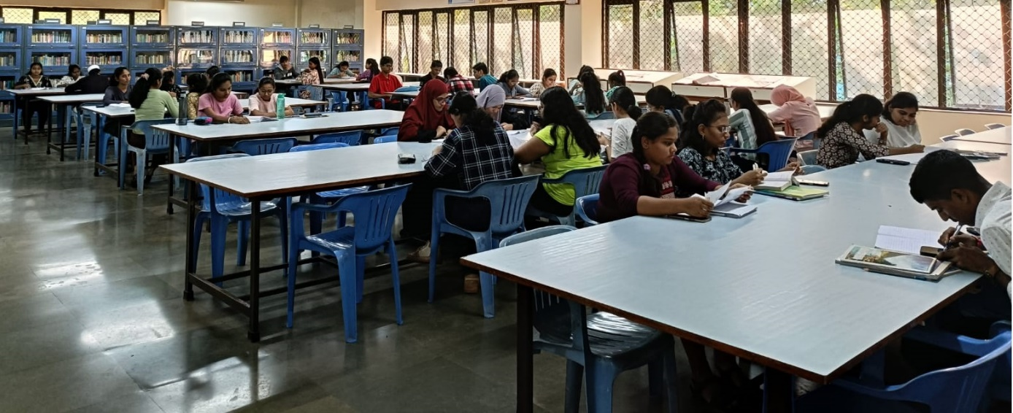

Group Book Reading

Saraswati Pooja by Principal Dr. Kaushal Prasad

Saraswati Pooja by Dr Yogesh Gajmal (Chairman, LAC)

Students visiting the exhibition.

Students visiting the exhibition.