 | HOPE Foundation’s
 | Finolex Academy of Management & Technology, Ratnagiri
 | Department of Information Technology

A Webinar on How to Be Placed in Multinational Companies

A webinar on “How to be Placed in Multinational Companies" was organized by the Department of Information Technology from 25th January 2023 to 26th January 2023. This webinar was organized for TEIT & BEIT students for providing valuable guidelines regarding how to get placed in multinational companies.
This event focused on:
- Realizing the reasons why engineers struggle to get good jobs.
- Understanding how MNCs shortlist profiles.
- Using important keywords in a resume to attract attention.
- Discussion on how to appear for an interview with confidence.
The program was initiated by Head of IT, Dr Vinayak A. Bharadi and organized by Prof. Shashank S. Tolye & Prof. Omkar D. Dike. The event was conducted online as a webinar. The resource person for the session was Mr Umesh Yadav from IIT Bombay Training Department. A total of 39 students enthusiastically attended the program and were satisfied by the valuable knowledge delivered by Mr Umesh Yadav.

Photographs
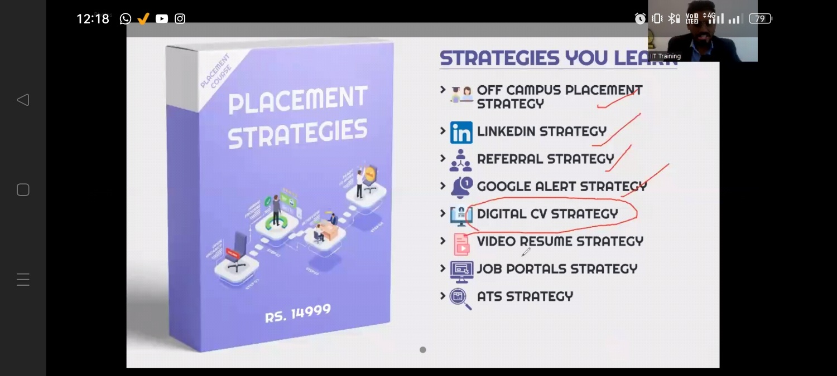
Resource person Mr Umesh Yadav explaining strategies of selection

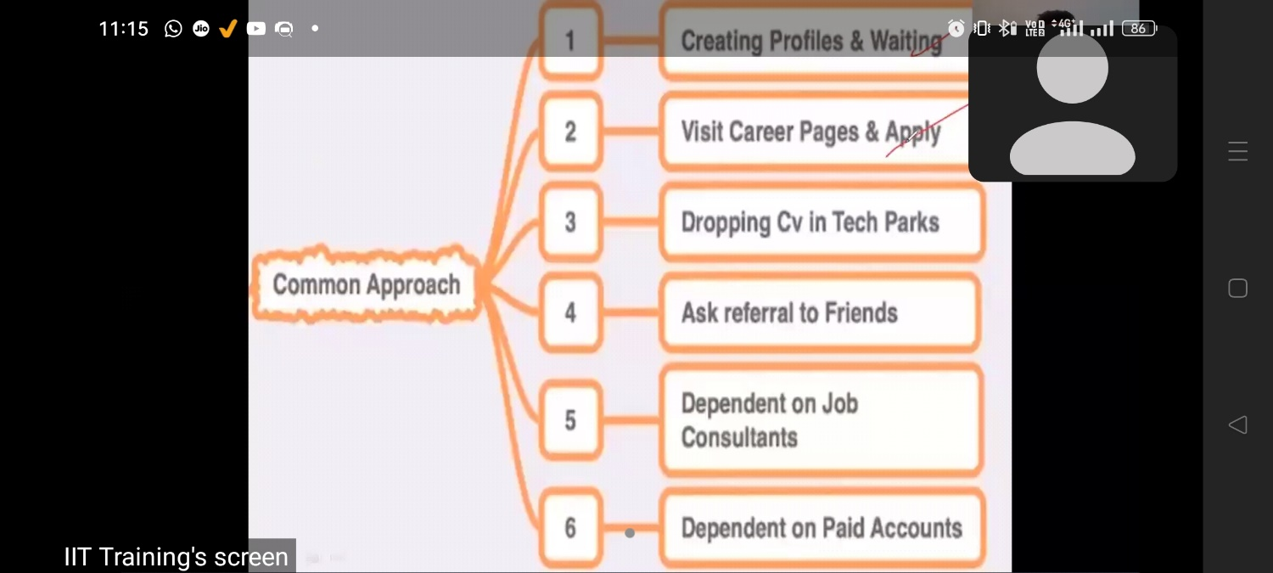
Discussion regarding different approaches for applying to a job.

