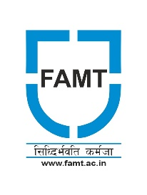
Hope Foundation’s
Finolex Academy of Management & Technology, Ratnagiri
----------------------------------------------------------------------
FAMT Celebrates Azadi Ka Amrit Mahotsav

FAMT is organizing various activities to celebrate Azadi Ka Amrit Mahotsav on 75th Independence Day. The Sports Committee of Finolex Academy of Management and Technology, Ratnagiri organized a Marathon for FAMT Students on 10th August 2022.
The marathon aimed to promote interaction and mutual understanding among students, health awareness, unity in diversity and national sprit.
More than 150 students (Boys & Girls) have enthusiastically participated in this event. The event was organised under the guidance of Principal Dr. Kaushal Prasad, Dr. Sanjay B Kulkarni, Prof. Prashant A Giri, Mr. Amey Raikar and Team FAMT.
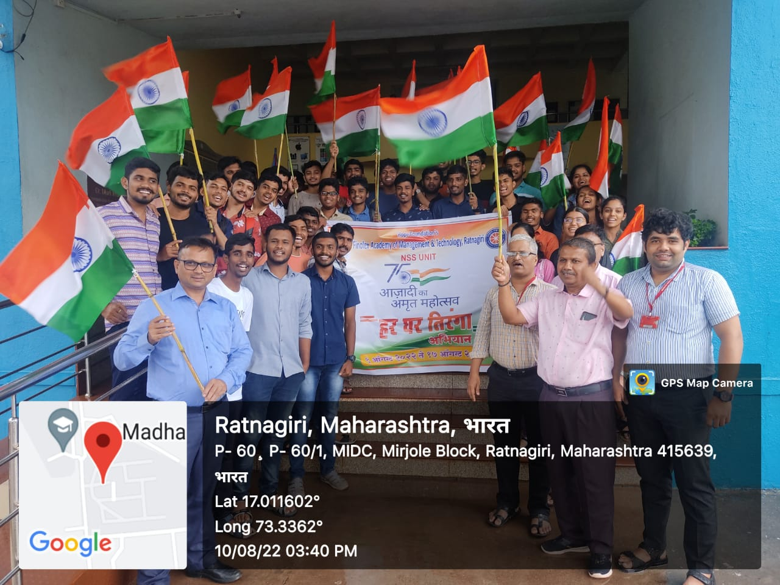

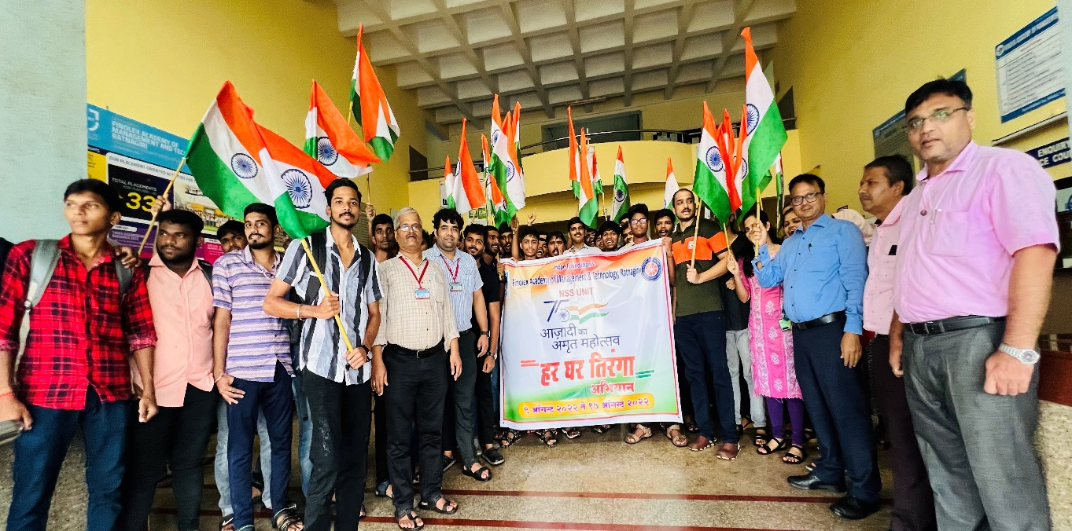
Dr. Kaushal Prasad Principal FAMT, Dr. Sanjay B. Kulkarni and Prof. Prashant A. Giri with students participating in Marathon
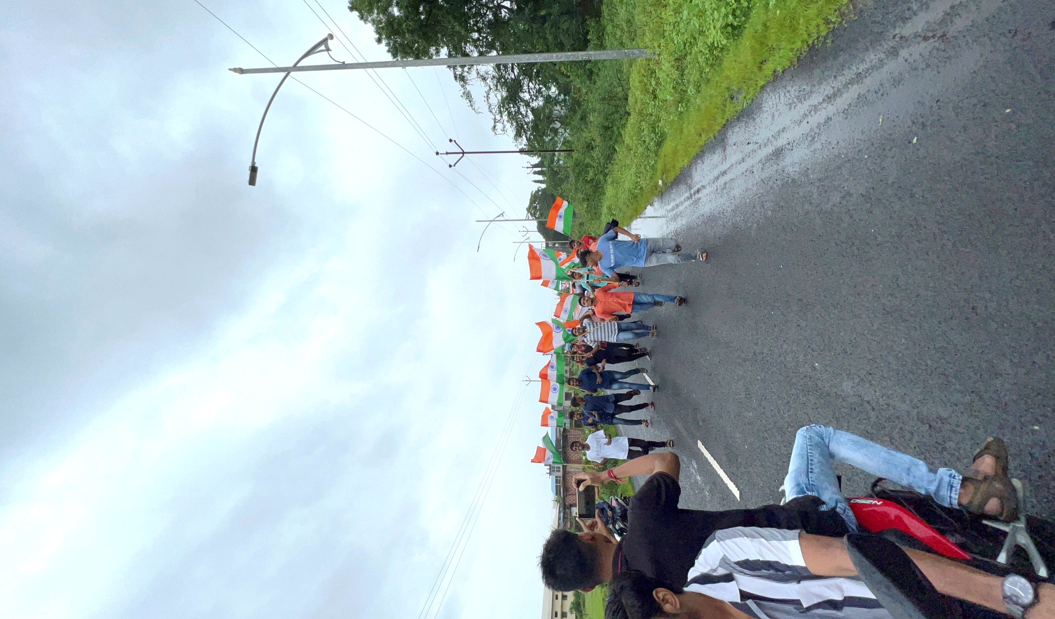
Students’ participation in Marathon
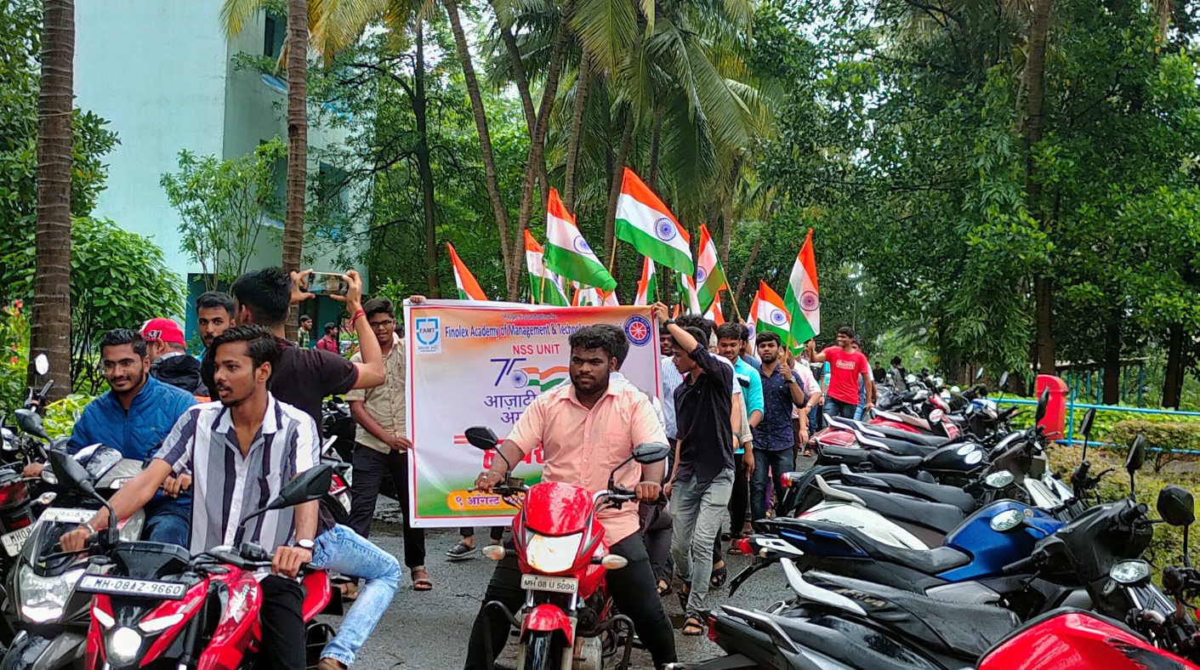
Students Faculty participation in Rally

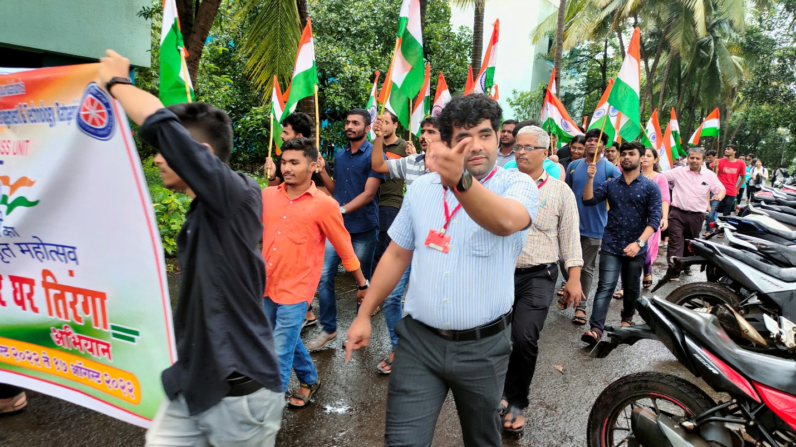
Students and Faculty participation in Rally

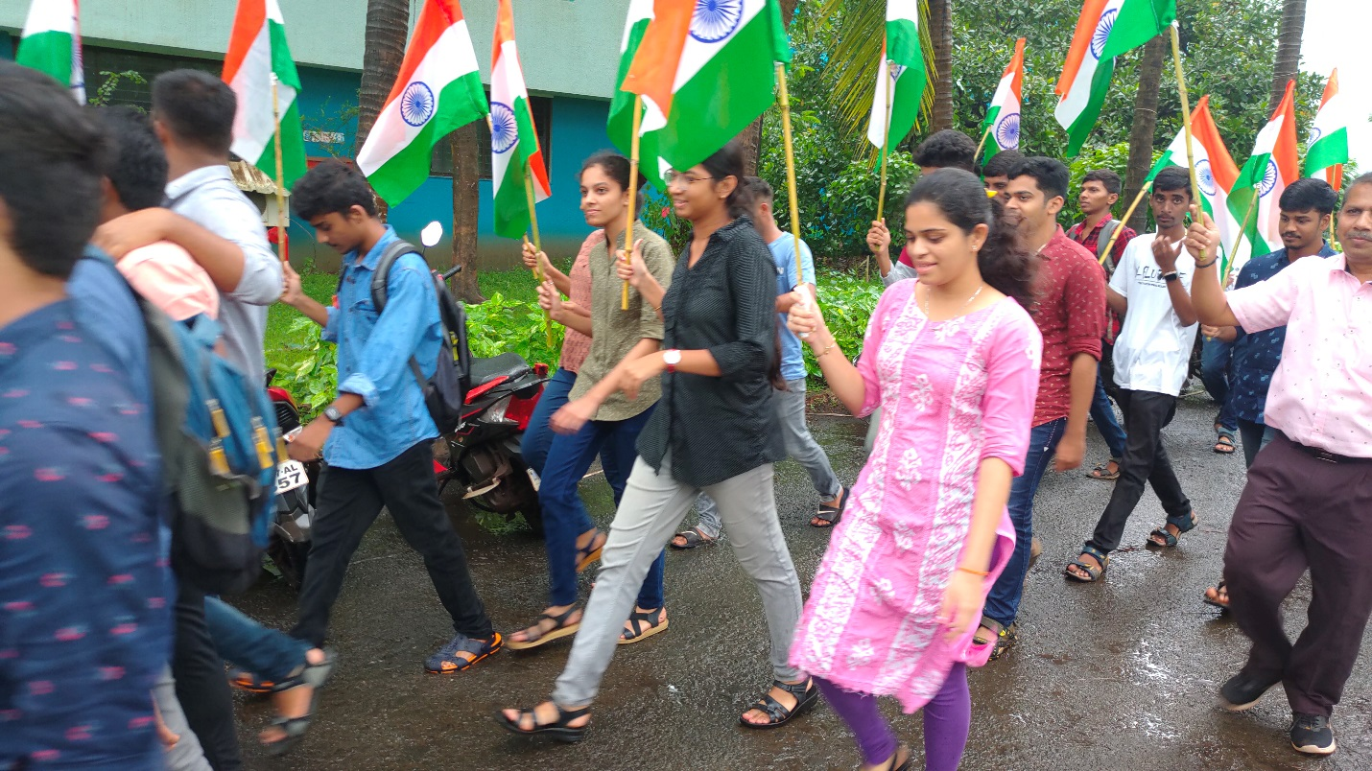
Students and Faculty participation in Rally

