Solid Fluid Mechanical Operations
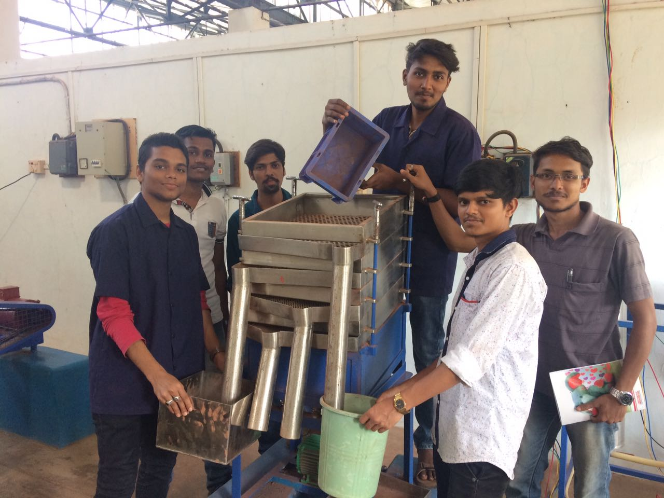
Faculty in charge | Prof. Raju K. Marag
Laboratory Area | 120 m²
Location | W-13
Seating Capacity | 20
Infrastructure & Facility | - Students Table:2,  - Stool:20,  - Faculty Table :1,  - Faculty Chair:1,  - Board:1,  - Tube Lights:7,  - Fans: 7.
List of Equipment Available | - Jaw Crusher  - Hammer Mill  - Ball Mill  - Plate and Frame Filter Press  - Sigma Mixer  - Sieving and PSD  - Test sieves  - Elutriation & PSD  - Vibrating screen  - Vacuum leaf filtration  - cyclone Separator  - Weighing balance

List of Experiments Performed | Even Sem  - Jaw Crusher  - Hammer Mill  - Ball Mill  - Plate and Frame Filter Press  - Sigma Mixer  - Sieving and PSD  - Test sieves  - Elutriation & PSD  - Vibrating screen  - Vacuum leaf filtration  - Cyclone Separator
Total Expenditure | 5,54,505 Rs.

