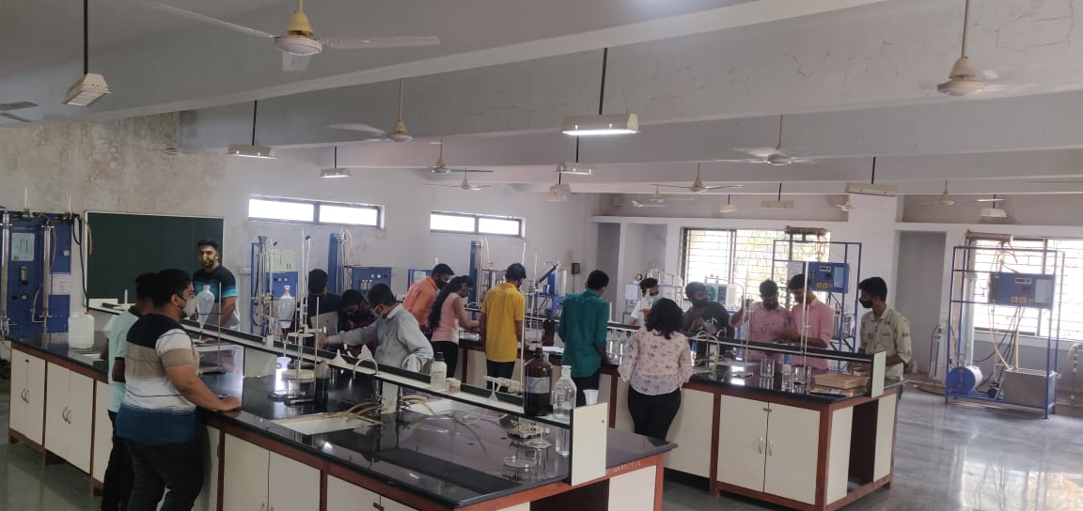
Mass Transfer Operations I & II

Faculty in charge | Prof. A. K. Bandsode
Laboratory Area | 204 m²
Location | C-01/01
Seating Capacity | 40
Infrastructure & Facility | Chairs =3, Black Board=01, Faculty Table=01,  Stools=30, Weighing Balance=01, Practical Table =02  Utilities: Water , Electrical and compressed air supply
List of Equipment Available | 18 Experimental Setup
List of Experiments Performed  Mass Transfer Operations-I | Odd Sem [MTO I]  - Rate of Drying Curve  - Cooling Tower  - Humidification And Dehumidification  - Surface evaporation  - Winkleman’s Experiment  - Solid Dissolution  - Liquid-Liquid Diffusion  - Hydrodynamics in Packed Column  - Wetted Wall Column  - Absorption in Packed column

List of Experiments Performed  Mass Transfer Operations-II | Even Sem [MTO II]  - Vapour-Liquid Equilibrium  - Flash Distillation  - Steam Distillation  - Distillation Under Total Reflux  - Sieve Plate Distillation  - Leaching  - Binodal Solubility Curve (L-L extraction)  - Adsorption  - Crystallisation  - Simple Distillation  - Ion Exchange
Total Expenditure | ₹273299

