Instrumentation and Process Control
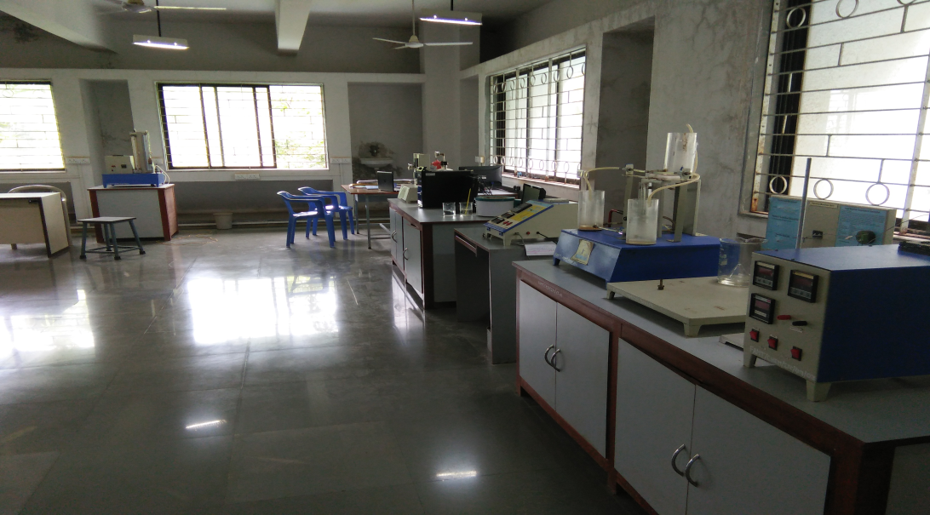

Faculty in charge | Prof. D. C. Dengale
Laboratory Area | $$120 m^{2}$$
Location | C-01/02, First Floor, Chemical Block
Seating Capacity | 20
Infrastructure & Facility | - 2 Student’s Tables  - 2 Faculty Tables  - 20 Stools
List of Equipment Available | - Dynamics Of First & Second Order System  - Dynamic Of Interacting Firstorder & Non Interacting Firstorder System.  - Temperature Measurement.  - Temperature Control Trainer.  - Pressure Control Trainer (314 A).  - Mini Compressor  - Compressor (7 Kg/Cm2).  - 03 Computers
List of Experiments Performed | Odd Sem  - Response of First Order System.  - Response of Second Order System.  - Response of Single Tank.  - Response of two tanks non-interacting system.  - Response of two tanks interacting system.  - Pressure Control Using ON-OFF Cntroller  - Development of empirical model for pressure tank  - Pressure Control Using Proportional Cntroller  - Pressure Control Using PI Cntroller  - Pressure Control Using PID Cntroller  Even Sem  Desmostration of various concepts in Instrumentation
Total Expenditure = | ` 3,24,908 Rs.

