Heat Transfer Operation(HTO)
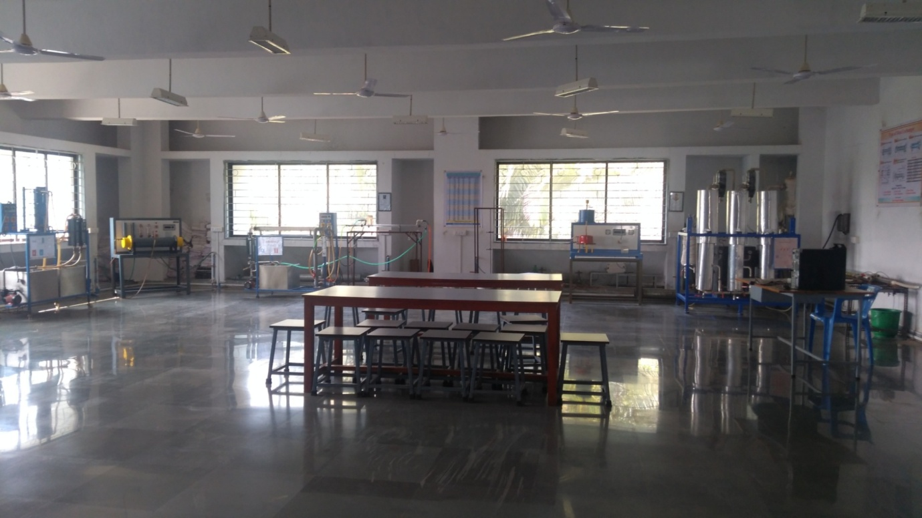

Faculty in charge | Prof. Y. A. Landge
Laboratory Area | 102 m²
Location | C-02/2
Seating Capacity | 20
Infrastructure & Facility | Faculty Table, Stools, Basic Utilities
List of Equipment Available | - Unsteady State of Heat Transfer  - Stefan Boltzman Apparatus  - Cross Flow Heat Exchanger  - Finned Tube Heat Exchanger  - Plate Heat Exchanger  - Film And Dropwise Condensation  - Jacketed Vessel
List of Experiments Performed | Odd Sem  - To estimate the film heat transfer coefficient between medium in which body is heated  - To verify Stefan Boltzmann constant  - To find the effectiveness & overall heat transfer coefficient of a Cross flow heat exchanger  - To determine overall heat transfer coefficient of finned tube heat exchanger  - To determine the overall heat transfer coefficient in a plate heat exchanger & its effectiveness  - To determine heat transfer coefficients for film and drop wise condensation of vapor on a copper tube  - To determine overall heat transfer coefficient, using water in the vessel and steam as the heating medium in inside the coil  - To determine overall heat transfer coefficient, using water in the vessel and steam as the heating medium in inside the jacket
Total Expenditure | 4,19,924 Rs.

