Fluid Flow Operation laboratory
Actual Photo of lab
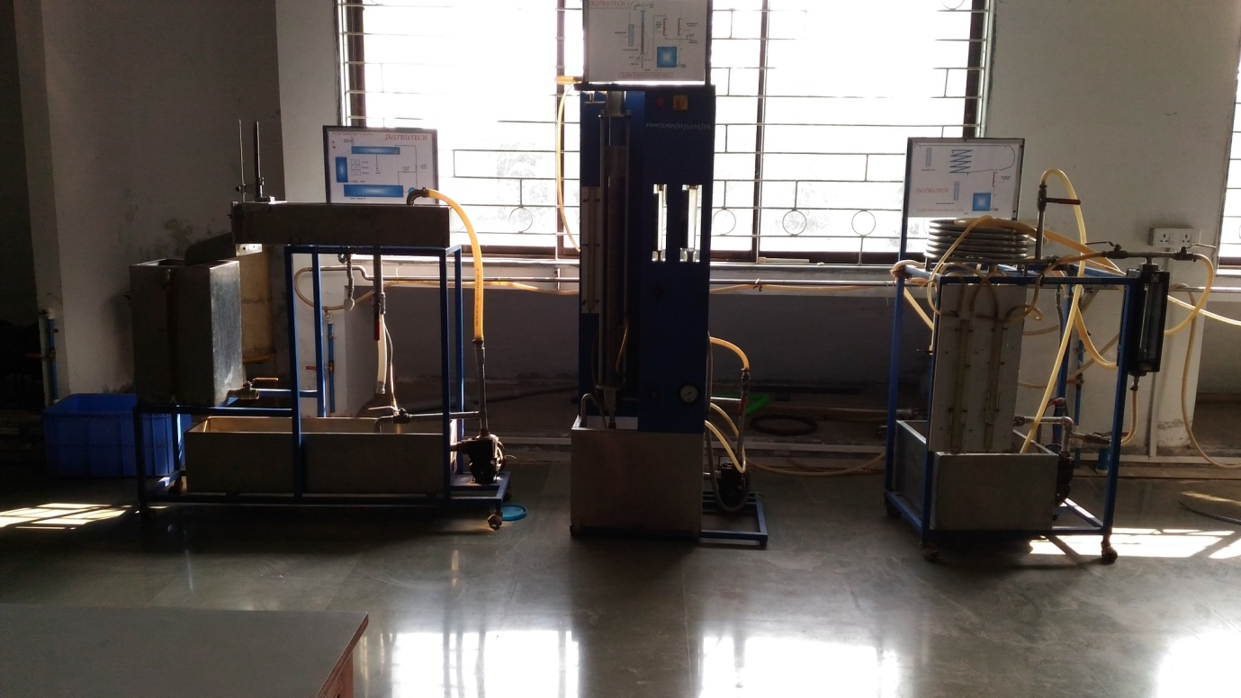

Faculty in charge | Mr. Prashant A. Giri
Laboratory Area | 102 m²
Location | C:02/02
Seating Capacity | 20 Sharing with HTO Lab
Infrastructure & Facility | Water connections  Black Board,  2 Student’s Tables (Sharing with HTO Lab)  2 Faculty Tables (Sharing with HTO Lab)  20 Stools (Sharing with HTO Lab)
List of Equipment Available | - FLUIDIZATION  - FLOW THROUGH NOTCHES  - FLOW THROUGH HELICAL COIL  - POWER CONSUMPTION IN AN AGITATED VESSEL  - EFFLUX TIME OF TANK  - FLOW THROUGH ANNULUS  - FLOW THROUGH FIXED BED  - AIR COMPRESSOR
List of Experiments Performed | Odd Sem:  - To determine pressure drop per unit bed length as a function of superficial velocity of fluidizing medium.  - To determine the coefficient of discharge for Orificemeter.  - To find the coefficient of discharge for a triangular and sharp-edged notch.  - To compare the pressure drop in helical coil with that in a straight pipe of same length, inside diameter and surface roughness.  - To determine the Reynolds’s number and hence the type of flow, either laminar or turbulent.  - To determine the power number for different impellers  - Determination of Viscosity of different densities Fluid by Measuring Efflux Time  - To calibrate the given Rotameter and draw it in the calibration curve.  - To estimate pressure drop for dry packing, wet drained packing and for two phase flow of air & water  - Determination of Viscosity of different densities Fluids  Even Sem: NA
Total Expenditure | Rs. 393,010.25

