Computer Application Laboratory
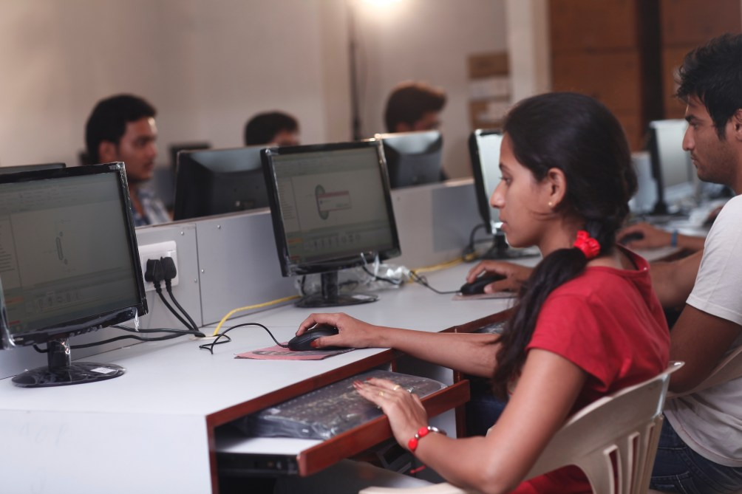

Faculty in charge | Prof. Shrikrishna Babar Bobde
Laboratory Area | 90 m²
Location | C-01/02
Seating Capacity | 30
Infrastructure & Facility | Computer Table=30  Chairs =30  Black Board=01  Faculty Table=01
List of Equipment Available | 30 Pc’s
List of Experiments Performed | Even Sem (IV Sem)  1. Successive Substitution  2. Newton’s Method  3. Regula Falsi Method  4. Gauss Jordan method  5. Gauss Seidel Method  6. Euler’s Method  7. Runge Kutta Method  8. Adam-Bashforth Method  9. Crank-Nicholson Method  10. Bender-Schmidt Method  Even Sem (VIII)  1. Simulation of Batch Reactor  2. Simulation of Continuous Stirred Tank Reactor (CSTR)  3. Simulation of flow sheet calculations  4. Four CSTR’s in Series Stage wise contacting equipment  5. Simulation of Plug Flow Reactor  6. Simulation of multi-component Flash Calculations  7. Simulation of absorption column  8. Data Regression
Total Expenditure = | 23,33,034.99 Rs.

