Chemical Reaction Engineering Laboratory (CRE)
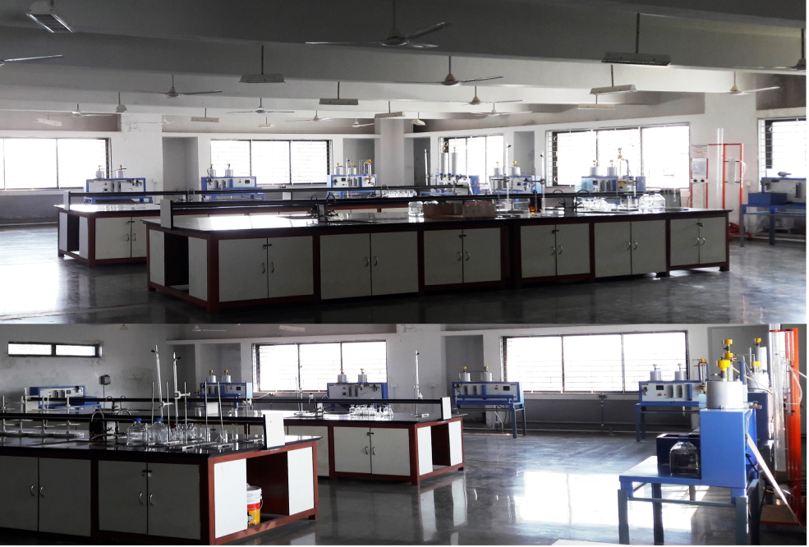

Faculty in charge | Prof. S. S. Kadlag
Laboratory Area | 202 m²
Location | C-2/01
Seating Capacity | 20
Infrastructure & Facility | - Refractometer  - Polarimeter  - Weighing Balance  - Refrigerator  - Air Compressor
List of Equipment Available | - Isothermal Plug Flow Reactor  - Isothermal CSTR/ Mixed Flow Reactor  - Three CSTR Connected in Series  - PFR And CSTR In Series  - Single Tube Isothermal Packed Bed Reactor  - RTDin CSTR/ Mixed Flow Reactor  - RTD in Plug Flow Reactor  - Single Tube Isothermal Packed Bed Reactor For RTD  - Helical Coil Reactor.
List of Experiments Performed | Odd Sem  - Saponification reaction in a batch reactor (Equimolar Mixture)  - Saponification reaction in a batch reactor (Non-Equimolar Mixture)  - Determination of activation energy using Arrhenius law.  - Acid catalyzed hydrolysis of methyl acetate.  - Study of inversion of sucrose  - Determination of order of reaction using different methods  - Study the performance of Mixed Flow Reactor.  - Study the performance of Plug Flow Reactor.  - Study the performance of Reactors in Series.  - Study the Performance of Packed Bed Reactor.  Even Sem:  - Determination of properties of solids.  - Adsorption of oxalic acid on activated Carbon.  - Study the effect of surface area on adsorption.  - RTDstudies of a CSTR/ Mixed Flow Reactor (Pulse Input).  - RTDstudies of a CSTR/ Mixed Flow Reactor (Step Input).  - RTD studies of a Plug Flow Reactor (Pulse Input).  - RTD studies of a Plug Flow Reactor (Step Input).  - RTD studies of aPacked Bed Reactor For RTD.
Total Expenditure | 5,67,048 Rs. (Fixed Cost)

